OBJECT CLASSIFICATION USING CONVOLUTIONAL NEURAL NETWORK (CNN) WITH CIFAR-10 DATASET
Virtual Data Science with Python Trainee Internship

Week 5 Task: Deep Learning Application in Data Science
Virtual Data Science with Python Internship
Submitted by: SNEHA YADAV
Course: Bachelor of Computer Applications (BCA)
University: Babasaheb Bhimrao Ambedkar University
Internship Organization: yuvaintern
Internship Program: Virtual Data Science with Python Trainee
Submission Date: 1-11-2026

ABSTRACT
This project focuses on developing an image classification system using Deep Learning and Convolutional Neural Networks (CNN). The main aim is to classify images into different object categories using the CIFAR-10 dataset.
The CIFAR-10 dataset contains 60,000 colour images divided into 10 different classes: airplane, automobile, bird, cat, deer, dog, frog, horse, ship and truck. Each image has a resolution of 32 × 32 pixels. The dataset contains 50,000 training images and 10,000 testing images.
Python and TensorFlow with Keras were used to develop the CNN model. The images were normalized and divided into training, validation and testing sets. The designed CNN architecture includes convolutional layers, batch normalization, max pooling, dropout and dense layers. The model was trained for 15 epochs using the Adam optimizer.
The model achieved a final test accuracy of 74.89% on 10,000 test images. Precision, recall, F1-score and a confusion matrix were also used to evaluate its classification performance. The results showed better classification performance for automobile, ship and truck images, while bird and cat images were more challenging for the model.
This project demonstrates how deep learning and CNNs can be used for multi-class image classification and provides practical understanding of model design, training and evaluation.

1. INTRODUCTION
Deep Learning is a part of Machine Learning that uses artificial neural networks to learn patterns from large amounts of data. It is widely used in applications such as image recognition, speech recognition, object detection and natural language processing.
One important application of Deep Learning is image classification. Image classification is the process of identifying an image and assigning it to a particular category.
In this project, a Convolutional Neural Network (CNN) is developed to classify images into ten different object categories using the CIFAR-10 dataset. CNN is a type of neural network specially designed for processing images. It automatically learns important features such as edges, shapes, textures and patterns from images.
The project uses Python and TensorFlow with Keras to build and train the CNN model. The model learns from training images and is then evaluated using separate test images to check its classification performance.
1.1 Project Overview
The main purpose of this project is to develop a deep learning model that can recognize and classify different objects from images. The CIFAR-10 dataset is used because it contains images from ten different classes.
The CNN model consists of convolutional layers, batch normalization, max pooling, dropout and dense layers. These layers help the model learn image features and make predictions.
The trained model achieved 74.89% test accuracy, showing that it can classify many images correctly. The project also uses a confusion matrix and classification report to understand the model's performance for each class.
This project provides practical experience in image preprocessing, CNN architecture design, model training and performance evaluation.

2. PROBLEM STATEMENT AND OBJECTIVES
2.1 Problem Statement
Identifying objects from images is an important task in computer vision. However, manually identifying and classifying a large number of images can be difficult and time-consuming.
Traditional image classification methods often require manual feature extraction. Deep Learning provides a better approach by allowing neural networks to automatically learn useful features from images.
The main problem addressed in this project is to develop a CNN-based model that can classify low-resolution colour images into ten different object categories using the CIFAR-10 dataset.
2.2 Objectives of the Project
The main objectives of this project are:
- To understand the basic concepts of Deep Learning and Convolutional Neural Networks.
- To use the CIFAR-10 dataset for multi-class image classification.
- To load, explore and preprocess image data.
- To normalize pixel values for better model training.
- To design a CNN architecture using TensorFlow and Keras.
- To train the model using training and validation datasets.
- To evaluate the trained model using test accuracy and loss.
- To analyse classification performance using precision, recall, F1-score and a confusion matrix.
- To identify the strengths and limitations of the developed model.
2.3 Expected Outcome
The expected outcome is a trained CNN model that can predict the correct category of an input image among the ten CIFAR-10 classes. The project also aims to analyse the model's performance and understand how CNNs are useful for image classifications

3. DATASET DESCRIPTION
3.1 Introduction to CIFAR-10 Dataset
The CIFAR-10 dataset is a popular dataset used for training and testing image classification models. It contains 60,000 colour images divided into 10 different classes.
Each image has a resolution of 32 × 32 pixels with three colour channels (RGB). The dataset is divided into 50,000 training images and 10,000 testing images.
3.2 Classes in the Dataset
The CIFAR-10 dataset contains the following ten classes:
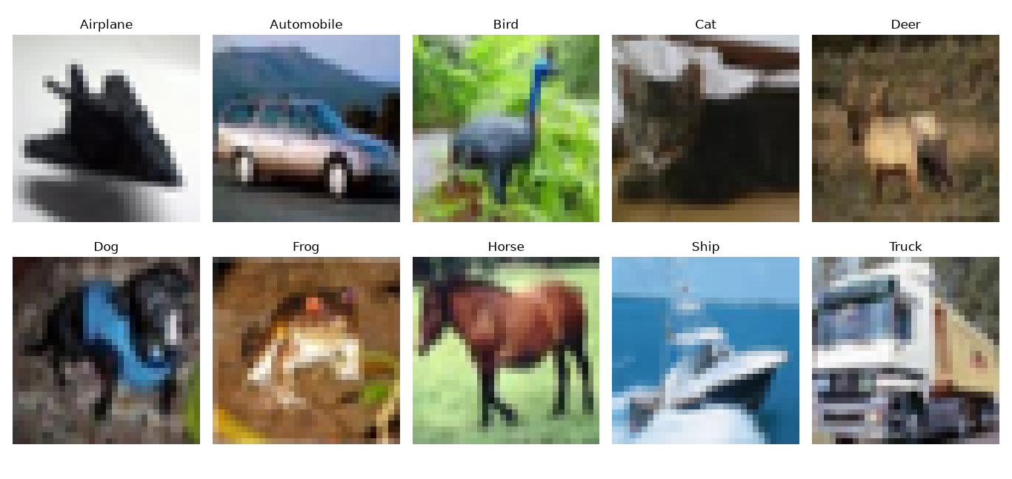Figure 3.1: Sample Images from the CIFAR-10 Dataset
1. Airplane 2. Automobile
3. Bird 4. Cat
5. Deer 6. Dog
7. Frog 8. Horse
9.Ship 10. Truck

3.3 Dataset Distribution
Dataset | Number of Images
Training Dataset | 50,000
Testing Dataset | 10,000
Total Images | 60,000
Each class contains 6,000 images in total, including 5,000 training images and 1,000 testing images.
3.4 Dataset Features
- Image Type: Colour images (RGB)
- Image Size: 32 × 32 pixels
- Number of Channels: 3
- Number of Classes: 10
- Total Images: 60,000
- Training Images: 50,000
- Testing Images: 10,000
3.5 Reason for Selecting CIFAR-10
CIFAR-10 was selected because it is a widely used dataset for image classification tasks. It contains different types of objects and provides a suitable opportunity to understand how CNN models learn visual features.
Its manageable size makes it useful for implementing and testing a deep learning model in a student-level project.

4. TOOLS AND TECHNOLOGIES USED
The project was developed using Python and various libraries required for deep learning and image classification. The following tools and technologies were used:
4.1 Python
Python is a programming language used to write the code, process the dataset and develop the deep learning model.
4.2 TensorFlow
TensorFlow is an open-source deep learning framework used to build, train and evaluate the CNN model.
4.3 Keras
Keras is a high-level deep learning API integrated with TensorFlow. It was used to create the CNN architecture and configure the training process.
4.4 NumPy
NumPy was used for numerical operations and handling image data in array format.
4.5 Matplotlib
Matplotlib was used to display sample images from the CIFAR-10 dataset and visualize training accuracy and loss.
4.6 Scikit-learn
Scikit-learn was used for splitting the dataset into training and validation sets and generating the classification report and confusion matrix.
4.7 Visual Studio Code (VS Code)
Visual Studio Code was used as the development environment to write, execute and manage Python code files.
4.8 System Requirements
- Operating System: Windows
- Programming Language: Python
- Development Environment: Visual Studio Code
- Deep Learning Framework: TensorFlow with Keras
- Dataset: CIFAR-10

5. DATA PREPROCESSING
Data preprocessing is an important step in deep learning. It helps prepare raw data in a suitable format so that the model can learn effectively. In this project, the CIFAR-10 dataset was preprocessed before training the CNN model.
5.1 Loading the Dataset
The CIFAR-10 dataset was loaded using the TensorFlow Keras datasets module. It was automatically divided into training and testing datasets.
The original dataset contains 50,000 training images and 10,000 testing images.
5.2 Image Normalization
The pixel values of the original images range from 0 to 255. These values were converted into floating-point numbers and divided by 255.
This changed the pixel range from 0–255 to 0–1. Normalization helps the model process image data more consistently during training.
Code Snippet:
x_train = x_train.astype('float32') / 255.0
x_test = x_test.astype('float32') / 255.0

5.3 Splitting the Training Dataset
The original training dataset was further divided into training and validation sets using Scikit-learn.
- Training Set: 45,000 images
- Validation Set: 5,000 images
- Testing Set: 10,000 images
The validation set was used to monitor model performance during training, while the test set was kept separate for final evaluation.

Code Snippet:
from sklearn.model_selection import train_test_split

x_train, x_val, y_train, y_val = train_test_split(
x_train, y_train,
test_size=0.1,
random_state=42,
stratify=y_train
)

5.4 Final Dataset Shape
After preprocessing and splitting, the dataset shapes were:
Dataset | Shape
Training | (45000, 32, 32, 3)
Validation | (5000, 32, 32, 3)
Testing | (10000, 32, 32, 3)

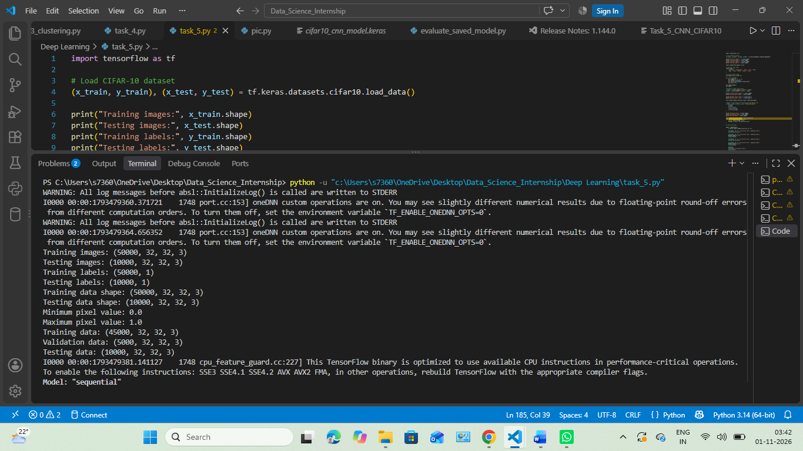
Figure 5.1: Dataset Preprocessing and Splitting Output

5.5 Importance of Preprocessing
Preprocessing made the image data suitable for CNN model training. Normalization brought all pixel values into a common range, while splitting the data provided separate sets for learning, validation and final testing. This helped in evaluating the model on images that were not used during training.
6. CNN ARCHITECTURE DESIGN
6.1 Introduction to CNN
A Convolutional Neural Network (CNN) is a type of deep learning model mainly used for image processing and image classification. It automatically learns important features such as edges, shapes, textures and patterns from images.
In this project, a CNN model was developed using TensorFlow and Keras to classify CIFAR-10 images into ten different categories.
6.2 Architecture of the CNN Model
The CNN model consists of multiple layers arranged in a sequence. Each layer performs a specific task to extract image features and make predictions.
The main layers used in the model are:
- Input Layer: Accepts colour images of size 32 × 32 pixels with three RGB channels.
- Convolutional Layer: Extracts important features such as edges, shapes and patterns from images.
- ReLU Activation: Introduces non-linearity and helps the model learn complex patterns.
- Batch Normalization: Helps maintain stable activations during training.
- Max Pooling Layer: Reduces the spatial dimensions of feature maps while retaining important information.
- Dropout Layer: Helps reduce overfitting by randomly disabling some neurons during training.
- Flatten Layer: Converts feature maps into a one-dimensional vector.
- Dense Layer: Learns relationships between extracted features.
- Output Layer: Uses Softmax activation to produce probabilities for the ten classes.

6.3 Model Configuration
The following configuration was used to build the CNN model:
Parameter | Value
Input Image Size | 32 × 32 × 3
Number of Classes | 10
Optimizer | Adam
Loss Function | Sparse Categorical Crossentropy
Activation Function | ReLU and Softmax
Total Parameters | 591,658
Trainable Parameters | 591,466
Non-trainable Parameters | 192
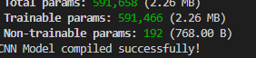

Figure 6.1: CNN Model Parameters and Successful Model Saving Output
6.4 Reason for Selecting CNN
CNN was selected because it is specially designed to process image data. It automatically extracts useful visual features and reduces the need for manual feature extraction.
The combination of convolution, pooling, batch normalization and dropout layers helps the model learn image patterns and improve classification performance.

7. MODEL TRAINING PROCESS
7.1 Introduction
After designing the CNN architecture, the model was compiled and trained using the preprocessed CIFAR-10 dataset. During training, the model learned patterns and features from the images to improve its classification performance.
7.2 Model Compilation
Before training, the CNN model was compiled using the following settings:
- Optimizer – Adam: Used to update model weights during training.
- Loss Function – Sparse Categorical Crossentropy: Used because the project involves classification into ten classes with integer labels.
- Evaluation Metric – Accuracy: Used to measure the percentage of correctly classified images.

7.3 Training Configuration
The following parameters were used during model training:
Parameter | Value
Epochs | 15
Batch Size | 64
Optimizer | Adam
Loss Function | Sparse Categorical Crossentropy
Training Images | 45,000
Validation Images | 5,000
7.4 Training Process
The model was trained for 15 epochs using the training dataset. After each epoch, its performance was checked on the validation dataset.
During training, the model's accuracy increased and its loss decreased. This indicates that the CNN gradually learned useful features from the images.

7.5 Training Results
The following results were observed during training:
Epoch | Training Accuracy | Validation Accuracy
1 | 17.90% | 26.44%
5 | 37.54% | 52.26%
10 | 66.85% | 70.86%
15 | 73.67% | 75.30%
The training accuracy increased from 17.90% to 73.67%, while validation accuracy reached 75.30% by the final epoch.
This shows that the model improved its learning performance over the training process.

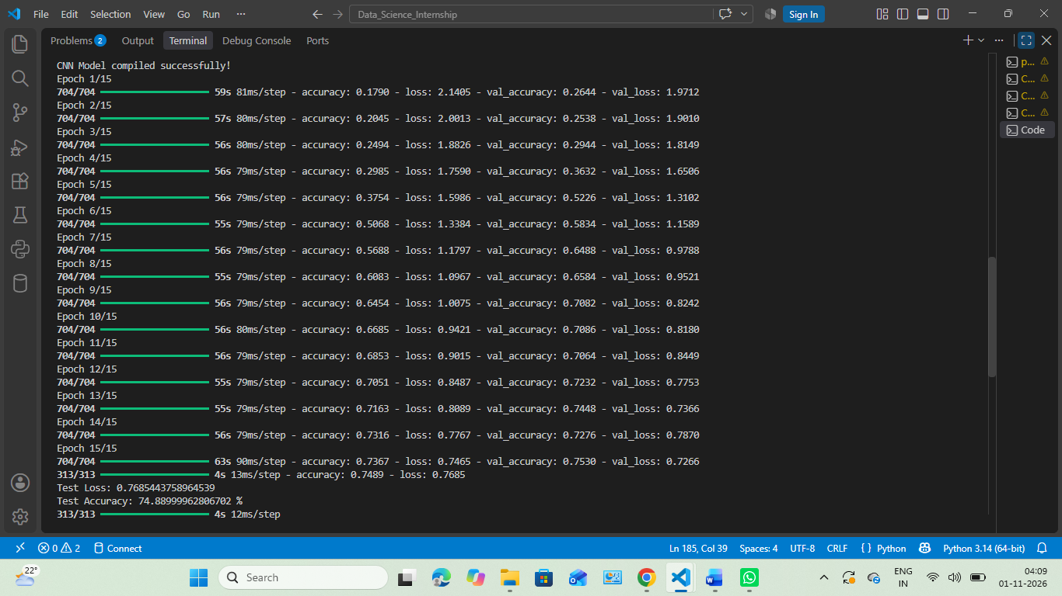
Figure 7.1: CNN Model Training Output

8. TRAINING ACCURACY AND LOSS ANALYSIS
8.1 Training Accuracy
Training accuracy measures how correctly the model classifies images from the training dataset.
During the 15 training epochs, the training accuracy increased from 17.90% in the first epoch to 73.67% in the final epoch.
This improvement indicates that the CNN model gradually learned useful features from the training images.
8.2 Validation Accuracy
Validation accuracy measures the model's performance on images that are not used for updating its weights during training.
The validation accuracy increased from 26.44% in the first epoch to 75.30% in the final epoch. This shows that the model was also able to perform well on unseen validation images.
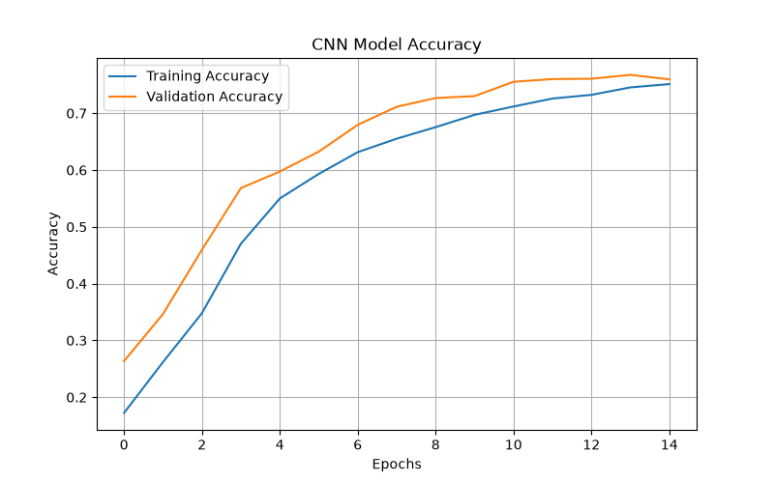
Figure 8.1: Training and Validation Accuracy

8.3 Training Loss
Training loss represents the difference between the model's predictions and the actual class labels during training.
The training loss decreased from 2.1405 in the first epoch to 0.7465 in the final epoch. A decrease in loss indicates that the model's predictions improved during training.
8.4 Validation Loss
Validation loss measures prediction errors on the validation dataset.
The validation loss decreased from 1.9712 in the first epoch to 0.7266 in the final epoch. This indicates that the model's performance improved on the validation data.
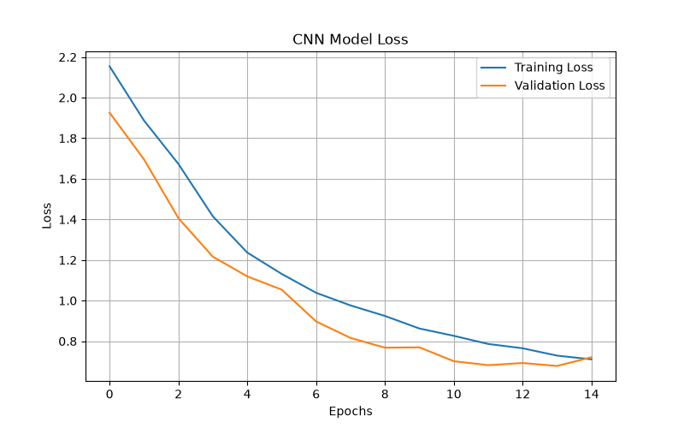
Figure 8.2: Training and Validation Loss
8.5 Overall Graph Analysis
The accuracy and loss graphs show an overall improvement in model performance during training. Training and validation accuracy increased, while both loss values decreased.
The training and validation results remained relatively close by the final epoch. This suggests that there was no large performance gap between the training and validation datasets in this run.

9. MODEL EVALUATION AND TEST RESULTS
9.1 Introduction
After completing the training process, the CNN model was evaluated using the test dataset. The test dataset contains 10,000 images that were not used during model training. This evaluation helps to measure how well the model can classify new and unseen images.
9.2 Test Performance
The trained CNN model was evaluated using the model.evaluate() function. The following results were obtained:
Evaluation Metric | Result
Test Loss | 0.7685
Test Accuracy | 74.89%
Total Test Images | 10,000
Correct Predictions | 7,489
Incorrect Predictions | 2,511
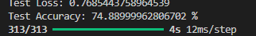
Figure 9.1: CNN Model Test Evaluation Output
9.3 Classification Report
Precision, recall and F1-score were used to evaluate the model's performance for each image class.
- Precision: Measures how many images predicted as a particular class were actually correct.
- Recall: Measures how many actual images of a class were correctly identified.
- F1-score: Represents the balance between precision and recall.

The classification report showed that the model performed best on automobile images, with an F1-score of 0.89. Ship and truck images also showed good results, with F1-scores of 0.87 and 0.86 respectively.
However, cat and bird images were more difficult to classify, with F1-scores of 0.52 and 0.62.
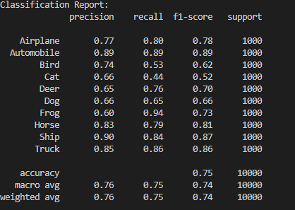
Figure 9.2: Classification Report of All Ten Classes
9.4 Evaluation Summary
The model achieved an overall test accuracy of 74.89%, which means it correctly classified 7,489 out of 10,000 test images. These results show that the CNN learned useful image features and can classify different object categories with reasonable accuracy. However, its performance varies across classes, so further improvements are possible.
10. CONFUSION MATRIX AND ITS INTERPRETATION
10.1 Introduction
A confusion matrix is used to evaluate the performance of a classification model. It compares the actual class labels with the predicted class labels. It helps us understand which classes are correctly classified and which classes are often confused by the model.

10.2 Confusion Matrix Results
The confusion matrix was generated using the predictions made by the trained CNN model on the test dataset of 10,000 images.
The diagonal values represent the number of correctly classified images for each class. The values outside the diagonal represent incorrect predictions.
The model correctly classified 7,489 images out of 10,000 test images, achieving an accuracy of 74.89%.
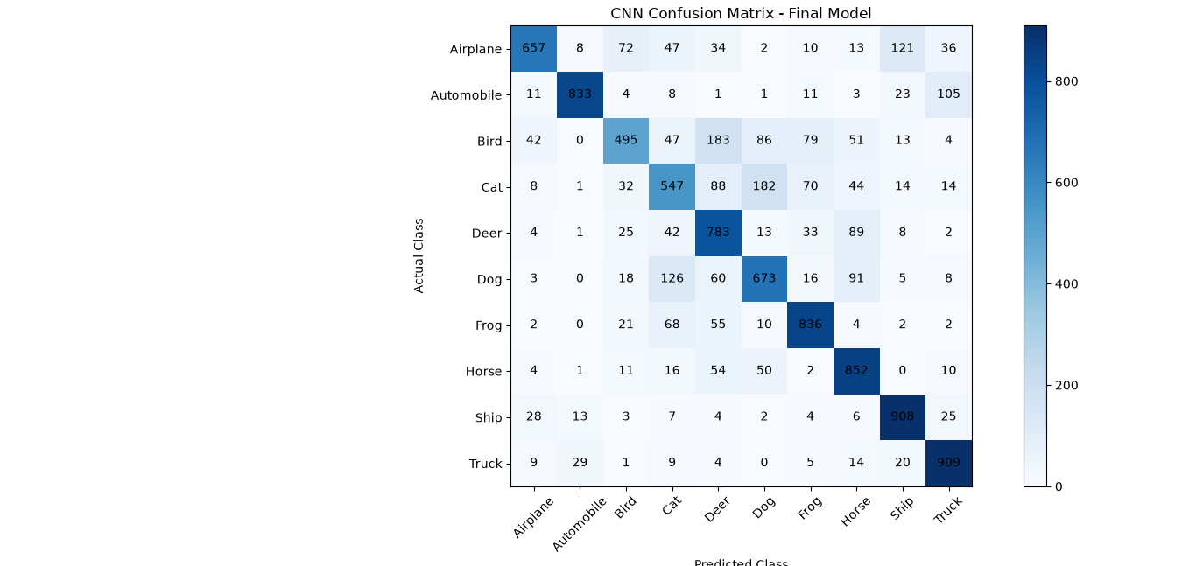
Figure 10.1: Confusion Matrix of CNN Model on Test Dataset
10.3 Class-wise Interpretation
The confusion matrix provides the following important observations:
- Automobile: 887 images were correctly classified, showing strong performance.
- Ship: 840 images were correctly classified.
- Truck: 862 images were correctly classified.
- Frog: 940 images were correctly classified, the highest among all classes.
- Cat: Only 436 images were correctly classified, showing that this class was challenging.
- Bird: 529 images were correctly classified, indicating difficulty in identifying some bird images.
The model also confused some visually similar animal classes. For example, 192 cat images were predicted as frogs, and 169 cat images were predicted as dogs.

10.4 Overall Interpretation
The confusion matrix shows that the CNN model performed better on several vehicle categories than on some animal categories. This may be because low-resolution images contain limited visual details, making certain animal classes difficult to distinguish.
The results also show that overall accuracy alone does not explain the complete performance of a classification model. Class-wise evaluation is important for identifying strengths and weaknesses.

11. RESULTS AND DISCUSSION
11.1 Overall Model Performance
The CNN model achieved a test accuracy of 74.89% after training for 15 epochs. It correctly classified 7,489 images out of 10,000 test images. The training accuracy reached 73.67%, while validation accuracy reached 75.30%.
These results indicate that the model learned useful features from the CIFAR-10 dataset and was able to classify unseen images with reasonable accuracy.
11.2 Comparison of Class-wise Performance
The model did not perform equally well on all ten classes.
Automobile achieved the highest F1-score of 0.89, followed by ship with 0.87 and truck with 0.86. This indicates that the model identified these categories more accurately.
On the other hand, cat achieved an F1-score of 0.52 and bird achieved 0.62. These classes were more challenging for the model.
11.3 Reasons Behind Classification Errors
Some possible reasons for incorrect predictions are:
- Low Image Resolution: CIFAR-10 images have a resolution of only 32 × 32 pixels, which limits visual details.
- Similar Features: Some animal classes have similar colours, textures and shapes.
- Background Variation: Different backgrounds and image conditions can make classification difficult.
- Limited Training: The model was trained for 15 epochs, so additional experiments may help improve its performance.

11.4 Training and Validation Analysis
The final training accuracy was 73.67%, and validation accuracy was 75.30%. The difference between them was small, suggesting that there was no large gap between training and validation performance.
Training and validation loss also decreased overall during training. This indicates that the model was learning from the dataset. However, further testing with different settings would be required to confirm its generalization performance.
11.5 Discussion
Overall, the CNN model demonstrated good learning capability for a basic multi-class image classification task. However, the differences in class-wise performance show that there is still room for improvement. The results highlight the importance of evaluating a model using multiple metrics instead of relying only on accuracy.
12. CHALLENGES AND SOLUTIONS
12.1 Challenges Faced
During the development of this CNN-based image classification project, some challenges were faced:
- Understanding CNN Architecture: Understanding the working of convolutional layers, pooling layers and dense layers required practice.
- Image Preprocessing: The images needed to be converted into a suitable numerical format and normalized before training.
- Training Time: Training a deep learning model on 45,000 images required computational time and resources.
- Classification Errors: The model sometimes confused visually similar classes, especially cat, dog, bird and frog images.
- Model Evaluation: Understanding precision, recall, F1-score and the confusion matrix required careful analysis.

12.2 Solutions Applied
The following steps were used to handle these challenges:
- CNN Architecture: Different CNN layers were studied and combined to build the classification model.
- Data Normalization: Pixel values were divided by 255 to scale them between 0 and 1.
- Training Configuration: The Adam optimizer and batch size of 64 were used to train the model.
- Overfitting Control: Dropout and batch normalization layers were included in the architecture.
- Performance Evaluation: Accuracy, loss, classification report and confusion matrix were used to evaluate the model.
12.3 Learning Outcomes
This project provided practical experience in loading image datasets, preprocessing images, designing CNN architecture, training deep learning models and evaluating classification results. It also improved understanding of how deep learning can be applied to real-world image classification problems.
13. LIMITATIONS OF THE PROJECT
Although the CNN model achieved a test accuracy of 74.89%, the project has some limitations.
13.1 Low Image Resolution
The CIFAR-10 dataset contains images of only 32 × 32 pixels. Due to this low resolution, some important visual details may not be clearly visible.
13.2 Classification Errors
The model sometimes confused visually similar classes, especially cat, dog, bird and frog. This affected the classification performance of these categories.
13.3 Limited Training Epochs
The model was trained for 15 epochs. Training with different epoch values and configurations may provide further improvements.

13.4 Limited Dataset
The model was trained and tested only on the CIFAR-10 dataset. Its performance on other image datasets has not been evaluated in this project.
13.5 Computational Requirements
Deep learning models require computational resources and training time. Larger datasets and more complex architectures may require better hardware.
13.6 Overall Limitation
The model provides reasonable classification performance, but it is not perfect. Further experiments, improved image processing and model optimization may help overcome some of these limitations.

14. FUTURE SCOPE AND IMPROVEMENTS
The current CNN model achieved a test accuracy of 74.89%. However, several improvements can be explored in the future to increase its classification performance.
14.1 Data Augmentation
Techniques such as image rotation, flipping, zooming and shifting can be used to create variations of training images. This may help the model learn better features.
14.2 Increasing Training Epochs
The model can be trained for more epochs with suitable monitoring. Early stopping can also be used to prevent unnecessary training and reduce overfitting.
14.3 Hyperparameter Tuning
Different learning rates, batch sizes, dropout values and numbers of filters can be tested to find a better model configuration.
14.4 Advanced CNN Architectures
More advanced architectures such as ResNet can be explored to improve feature extraction and classification performance.
14.5 GPU-Based Training
Using a GPU can reduce training time and make it easier to experiment with larger models and datasets.

14.6 Application Development
In the future, this model can be integrated into a simple web application where users can upload an image and receive its predicted class.
14.7 Expected Improvement
These improvements may help increase classification accuracy, reduce prediction errors and make the model more useful for practical image classification applications. These are proposed future improvements and were not implemented in the current project.

15. CONCLUSION
This project focused on developing an image classification model using Deep Learning and Convolutional Neural Networks (CNN) with the CIFAR-10 dataset.
The project provided practical experience in loading datasets, preprocessing images, designing CNN architecture, training a deep learning model and evaluating its performance using Python and TensorFlow with Keras.
The model was trained for 15 epochs and achieved a test accuracy of 74.89% on 10,000 test images. The classification report and confusion matrix helped identify the strengths and weaknesses of the model. It performed better on automobile, ship and truck images, while cat and bird images were more challenging to classify.
During this project, important concepts such as convolution, pooling, batch normalization, dropout, image normalization and model evaluation were understood through practical implementation.
Although the model achieved reasonable accuracy, there is still scope for improvement through data augmentation, hyperparameter tuning and advanced CNN architectures.
In conclusion, this project successfully demonstrated how Convolutional Neural Networks can be used for multi-class image classification. It also improved practical knowledge of deep learning and its applications in computer vision.

16. REFERENCES
The following resources were used for understanding the dataset, deep learning concepts and implementation of the CNN model.
- CIFAR-10 Dataset – University of Toronto
https://www.cs.toronto.edu/~kriz/cifar.html
- TensorFlow Keras CIFAR-10 Dataset Documentation
https://www.tensorflow.org/api_docs/python/tf/keras/datasets/cifar10
- TensorFlow Official Documentation
https://www.tensorflow.org/
- Keras Documentation
https://keras.io/
- NumPy Documentation
https://numpy.org/doc/
- Matplotlib Documentation
https://matplotlib.org/stable/
- Scikit-learn Documentation
https://scikit-learn.org/stable/
These resources helped in understanding image classification, dataset handling, CNN implementation, visualization and model evaluation.

17. APPENDIX
Appendix A: Main Python Source Code
File Name: task_5.py
import tensorflow as tf

# Load CIFAR-10 dataset
(x_train, y_train), (x_test, y_test) = tf.keras.datasets.cifar10.load_data()

print("Training images:", x_train.shape)
print("Testing images:", x_test.shape)
print("Training labels:", y_train.shape)
print("Testing labels:", y_test.shape)

import matplotlib.pyplot as plt

# CIFAR-10 class names
class_names = [
'Airplane', 'Automobile', 'Bird', 'Cat', 'Deer',
'Dog', 'Frog', 'Horse', 'Ship', 'Truck'
]

# Display sample images
plt.figure(figsize=(10, 5))

for i in range(10):
plt.subplot(2, 5, i + 1)
plt.imshow(x_train[i])
plt.title(class_names[y_train[i][0]])
plt.axis('off')

plt.tight_layout()
plt.show()

# Normalize image pixel values
x_train = x_train.astype('float32') / 255.0
x_test = x_test.astype('float32') / 255.0

print("Training data shape:", x_train.shape)
print("Testing data shape:", x_test.shape)

print("Minimum pixel value:", x_train.min())
print("Maximum pixel value:", x_train.max())

from sklearn.model_selection import train_test_split

# Split training data into training and validation sets
x_train, x_val, y_train, y_val = train_test_split(
x_train,
y_train,
test_size=0.1,
random_state=42,
stratify=y_train
)

print("Training data:", x_train.shape)
print("Validation data:", x_val.shape)
print("Testing data:", x_test.shape)

from tensorflow.keras.models import Sequential
from tensorflow.keras.layers import (
Conv2D, MaxPooling2D, Dense,
Flatten, Dropout, BatchNormalization
)

# Create CNN model

model = Sequential([
tf.keras.layers.Input(shape=(32, 32, 3)),

Conv2D(32, (3, 3), activation='relu', padding='same'),
BatchNormalization(),

Conv2D(32, (3, 3), activation='relu', padding='same'),
MaxPooling2D((2, 2)),
Dropout(0.25),

Conv2D(64, (3, 3), activation='relu', padding='same'),
BatchNormalization(),

Conv2D(64, (3, 3), activation='relu', padding='same'),
MaxPooling2D((2, 2)),
Dropout(0.25),

Flatten(),
Dense(128, activation='relu'),
Dropout(0.5),
Dense(10, activation='softmax')
])

# Display model architecture
model.summary()

# Compile the CNN model
model.compile(
optimizer='adam',
loss='sparse_categorical_crossentropy',
metrics=['accuracy']
)

print("CNN Model compiled successfully!")

# Train the CNN model
history = model.fit(
x_train,
y_train,
epochs=15,
batch_size=64,
validation_data=(x_val, y_val)
)

import matplotlib.pyplot as plt

# Accuracy graph
plt.figure(figsize=(8, 5))
plt.plot(history.history['accuracy'], label='Training Accuracy')
plt.plot(history.history['val_accuracy'], label='Validation Accuracy')
plt.title('CNN Model Accuracy')
plt.xlabel('Epochs')
plt.ylabel('Accuracy')
plt.legend()
plt.grid(True)
plt.savefig('accuracy_graph.png')
plt.show()

# Loss graph
plt.figure(figsize=(8, 5))
plt.plot(history.history['loss'], label='Training Loss')
plt.plot(history.history['val_loss'], label='Validation Loss')
plt.title('CNN Model Loss')
plt.xlabel('Epochs')
plt.ylabel('Loss')
plt.legend()
plt.grid(True)
plt.savefig('loss_graph.png')
plt.show()

# Evaluate model on test data
test_loss, test_accuracy = model.evaluate(x_test, y_test)

print("Test Loss:", test_loss)
print("Test Accuracy:", test_accuracy * 100, "%")

from sklearn.metrics import classification_report, confusion_matrix
import numpy as np
import matplotlib.pyplot as plt

# Predict test images
y_pred = model.predict(x_test)

# Convert probabilities into class labels
y_pred_classes = np.argmax(y_pred, axis=1)
y_true = y_test.flatten()

# Classification report
print("Classification Report:")
print(classification_report(
y_true,
y_pred_classes,
target_names=class_names
))

# Confusion matrix
cm = confusion_matrix(y_true, y_pred_classes)

plt.figure(figsize=(10, 8))
plt.imshow(cm, cmap='Blues')
plt.title('CNN Confusion Matrix')
plt.xlabel('Predicted Class')
plt.ylabel('Actual Class')
plt.xticks(range(10), class_names, rotation=45)
plt.yticks(range(10), class_names)
plt.colorbar()

for i in range(10):
for j in range(10):
plt.text(j, i, cm[i, j], ha='center', va='center')

plt.tight_layout()
plt.savefig('confusion_matrix.png')
plt.show()

# Save the trained CNN model
model.save("cifar10_cnn_model.keras")

print("CNN model saved successfully!")

This file contains the main implementation of the CNN-based image classification project, including dataset loading, preprocessing, model development, training and evaluation.
Appendix B: Saved Model Evaluation Code
File Name: evaluate_saved_model.py
import tensorflow as tf
import numpy as np
import matplotlib.pyplot as plt
from sklearn.metrics import confusion_matrix

# Load CIFAR-10 test dataset
(_, _), (x_test, y_test) = tf.keras.datasets.cifar10.load_data()

# Normalize test images
x_test = x_test.astype("float32") / 255.0

# Load saved CNN model
model = tf.keras.models.load_model("cifar10_cnn_model.keras")

# Predict test images
predictions = model.predict(x_test)
y_pred = np.argmax(predictions, axis=1)
y_true = y_test.flatten()

# Class names
class_names = [
'Airplane', 'Automobile', 'Bird', 'Cat', 'Deer',
'Dog', 'Frog', 'Horse', 'Ship', 'Truck'
]

# Generate confusion matrix
cm = confusion_matrix(y_true, y_pred)

plt.figure(figsize=(10, 8))
plt.imshow(cm, cmap='Blues')
plt.title('CNN Confusion Matrix - Final Model')
plt.xlabel('Predicted Class')
plt.ylabel('Actual Class')
plt.xticks(range(10), class_names, rotation=45)
plt.yticks(range(10), class_names)
plt.colorbar()

for i in range(10):
for j in range(10):
plt.text(j, i, cm[i, j], ha='center', va='center')

plt.tight_layout()
plt.savefig('final_confusion_matrix.png')
plt.show()

This file contains the code used to load the trained CNN model, generate predictions, evaluate classification performance and create the confusion matrix.

